1. a)

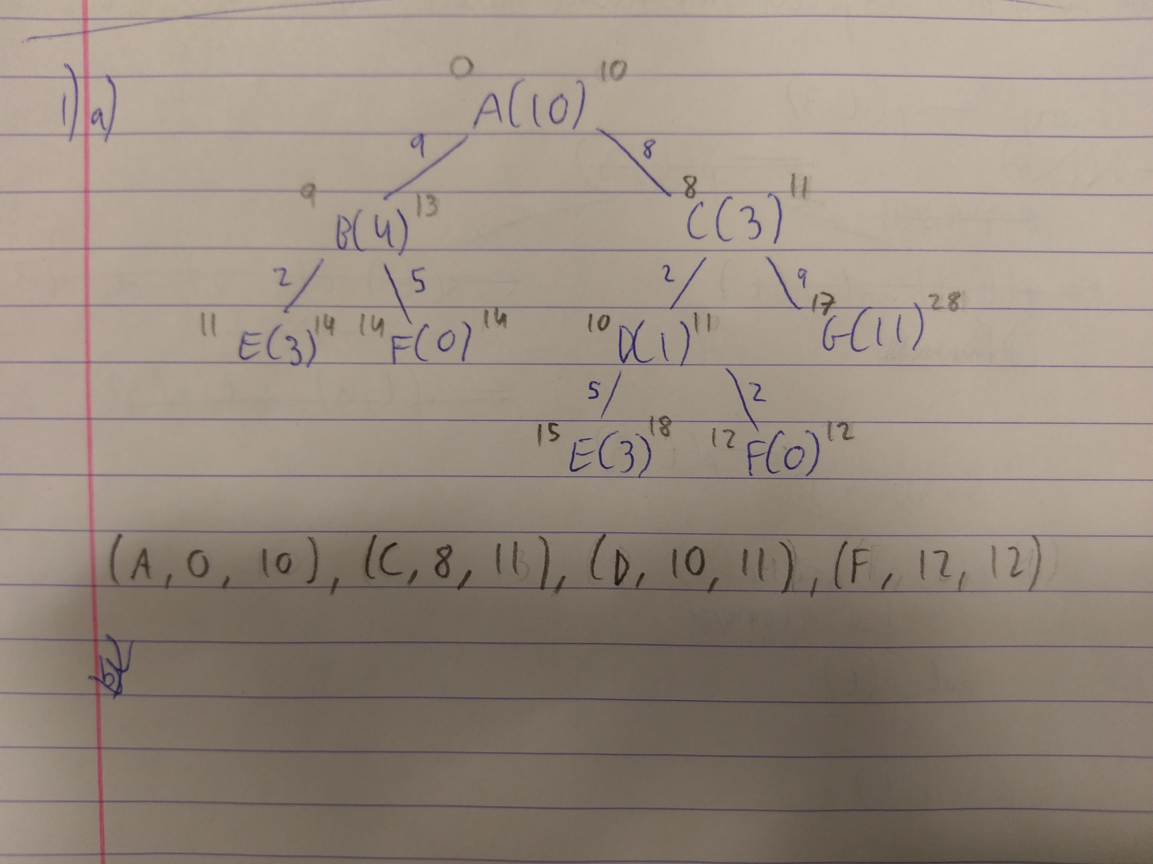

b)

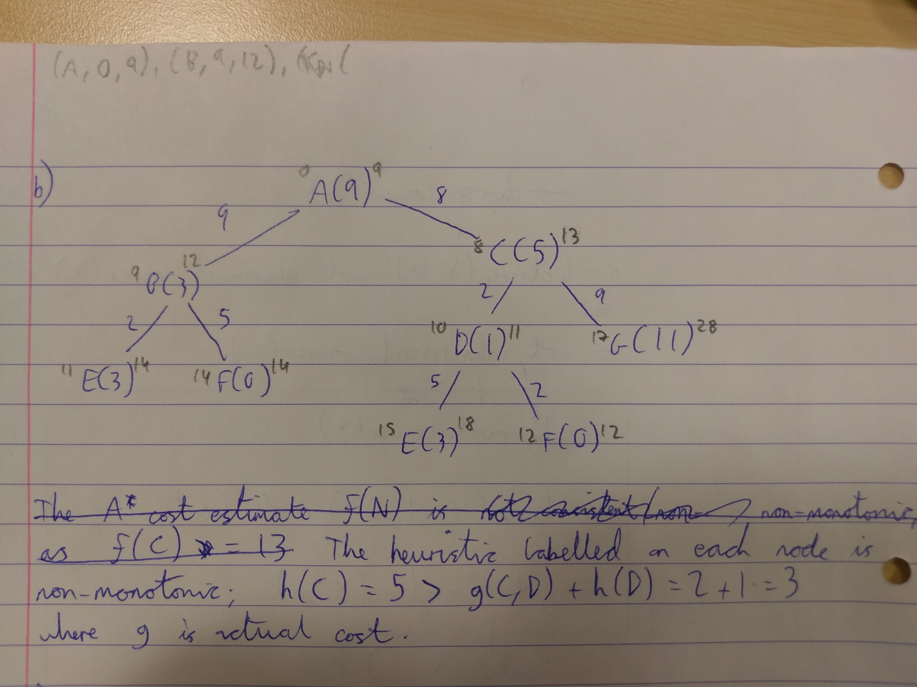

c) … [Given a goal, knowledge base and a set of abducibles, abduction calculates an explanation for the goal in terms of ground abducibles]

Event Calculus Planning takes a goal, rules for actions (knowledge base), and a set of possible actions (abducibles) and generates a plan in terms of the actions taken to satisfy the goal.

2) a)

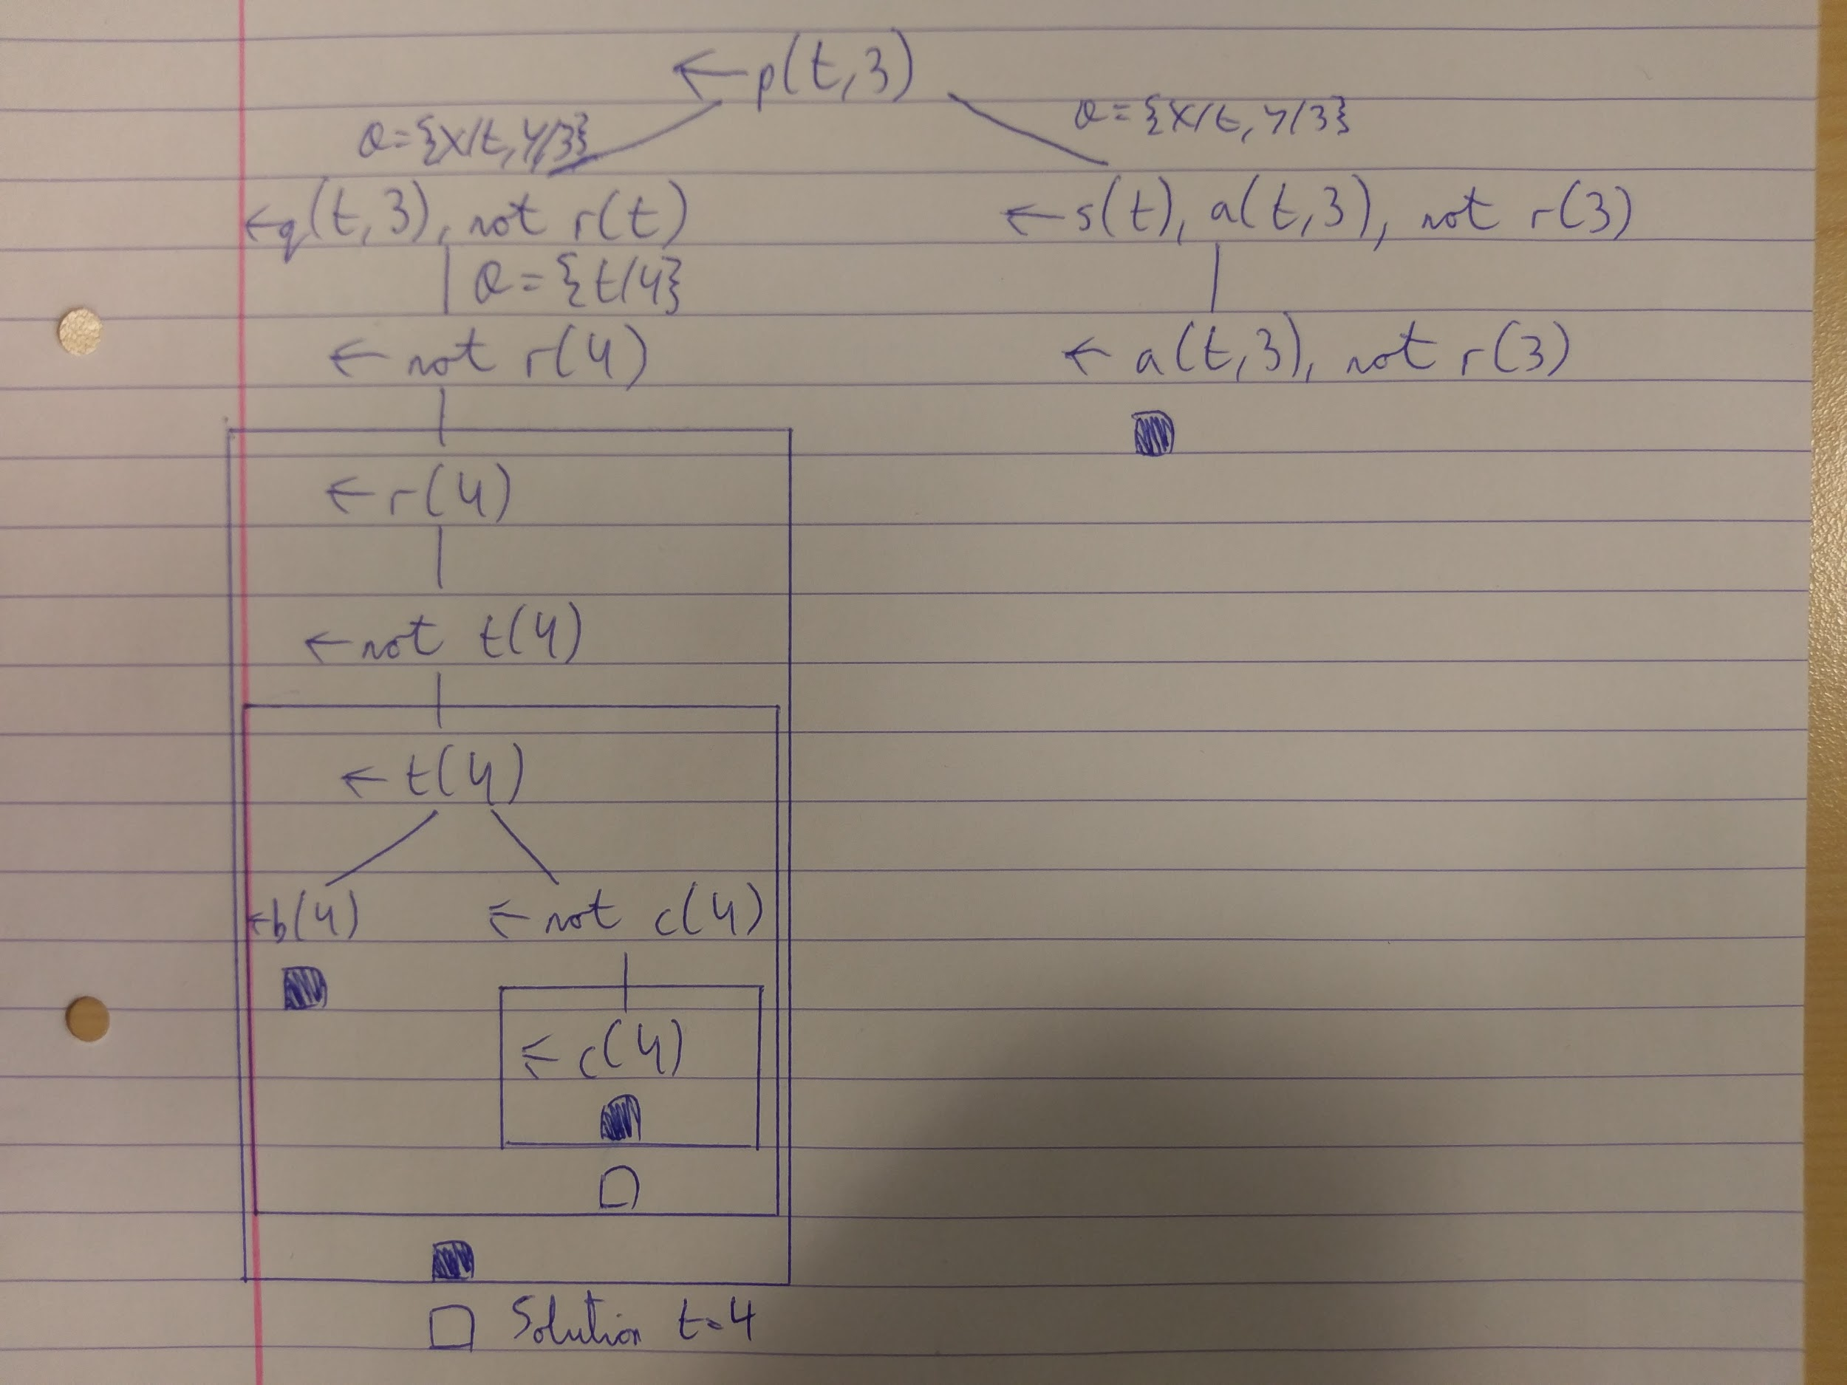

2) b) Not quite standard format, correct me if I'm wrong

